Modern World History – The Age of Imperialism Name: ___________________________
The Sun Never Sets on the British Empire
At its peak, the British Empire was the largest formal empire the world had ever known.
As such, its power and influence stretched all over the globe.
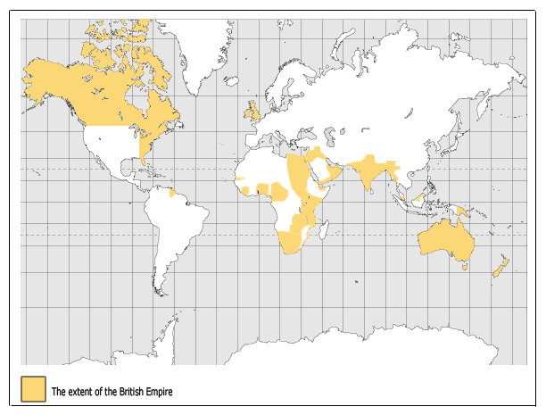
During the Age of Imperialism, it was often said that “The Sun Never Sets on the British Empire” –
explain the meaning of this statement:
The British Empire
- Areas of British control and influence during the Age of Imperialism:
  - India, Egypt, South Africa, Canada, Australia, New Zealand, Nigeria, Kenya, Sudan, … (and more)
- Developed two types of colonies
  - Like India: _____________________________________________________________________________________
  - Like Australia: small indigenous population was devastated, _____________________________________________
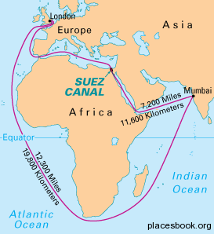
British Strategy
- Took areas that were of prime geographic location
  - Referred to as ‘_________________________’: the taking of land for strategic purposes
- Chief examples—
  - India: “______________________________________”
    - Abundant in rich resources; 300 million people, providing a large market and labor force
  - Egypt (Suez Canal): “___________________________”
    - Allowed Britain quicker access to its colonies in Asia and Africa
British Raj (Rule over India)
- British rule over India lasted from 1700-1947
- India was Britain's brightest jewel—the most valuable of Britain’s many colonies
- British imposed harsh economic restrictions:
  - India was to produce materials for British manufacturing and buy British finished goods
  - _________________________________________________________________________

Impacts of British Rule, through primary sources:
- Dadabhai Naoroji, an Indian, describes the effect of imperialism on India:
Europeans [the British] occupy almost all the higher places in every department of government . . . Natives, no matter how fit, are deliberately kept out of the social institutions started by Europeans . . . All they [the Europeans] do is live off of India while they are here. When they go, they carry all they have gained.
- This excerpt is adapted from The Economic History of India Under Early British Rule, by an Indian, Romesh Dutt:
Englishmen . . . have given the people of India the greatest human blessing – peace. They have introduced Western education. This has brought an ancient and civilized nation in touch with modern sciences, and modern life. They have built an administration that is strong and efficient. They have framed wise laws and have established courts of justice.
- This excerpt is adapted from British historian, J.A.R. Marriott’s book, The English in India:
Means of communication have been developed. There are great numbers of bridges, more than 40,000 miles of railway, and 70,000 miles of paved roads. These testify to the skill and industry of British engineers. Irrigation works on a very large scale have brought 30 million acres under cultivation. This has greatly added to the agricultural wealth of the country. Industrialization has also begun. India now has improved sanitation and a higher standard of living. It has a fine transport system and carefully thought-out schemes for relief work.
- This excerpt, from India: A Restatement by British writer Sir Reginald Coupland, points out the social and economic impact of imperialism on India:
British rule brought with it from the West certain standards of humanity that Indian society had not yet reached. Early action was taken to stop infanticide [the killing of girl babies] . . . The slave trade was ended and the owning of slaves was forbidden.
- This excerpt, from The Discovery of India, by Jawaharlal Nehru, explains how India became a “typical” colonial economy:
Old Indian industries – shipbuilding, metalwork, glass, paper – and many crafts were broken up. Thus the economic development of India was stopped and the growth of new industry was prevented . . . A typical colonial economy was built up. India became an agricultural colony of industrial England. It supplied raw materials and provided markets for England’s industrial goods. The destruction of industry led to unemployment on a vast scale . . . The poverty of the country grew. The standard of living fell to terribly low levels.
- This excerpt, from the History Learning Site, details how India was negatively impacted by British imperialism: The British disregarded Indian culture and religion (prime example: Sepoy Rebellion). The British segregated society, relegating Indians to a second-class status where their inferiority was felt at all moments. The British forced Indians out of their manufacturing jobs to do farm work and produce cash crops, which led to massive poverty. The British increased taxation, but limited ways for Indians to make money. Finally, the Indians only got democracy when the British left (in 1947).

Extract from the sources above a list of positive and negative impacts of colonization:
Positive Impacts | Negative Impacts

Indians Rebel, 1857
- Indian ____________ (soldiers employed by the British) led a massive, but unsuccessful, rebellion that lasted several months
  - The Sepoy Mutiny
- In 1857, sepoys discovered that the British were sealing cartridges for new rifles with ________________________________ to preserve the gunpowder
  - To use, soldiers had to bite off the seal
  - Both Hindus, who consider the cow sacred, and Muslims, who do not eat pork, were outraged by the news
- Many refused to accept the cartridges and were ____________________________________
Aftermath of the Sepoy Mutiny
- The mutiny fueled racist attitudes and increased distrust
- Large numbers of foreign officials were brought in to rule and assimilate Indians to British culture
- A strong nationalist movement began; two nationalist groups formed, demanding self-government:
  - ______________________________________________________
- A strong modernization/Westernization movement began
  - Some _________________________________________________________________________________________
  - Called for an end to widow suicide and the caste system
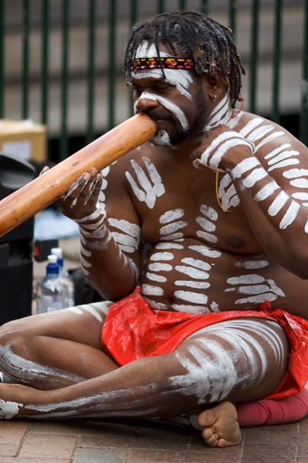
British Empire Case Study: Australia
Australia’s Pre-Modern History
The continent of Australia is approximately the size of the U.S. The first inhabitants of Australia, the aborigines, migrated there over 40,000-50,000 years ago, having migrated from Africa through Southeast Asia. They may have the oldest continuous culture on earth.
Aborigines were hunter-gatherers who practiced an animistic type religion that believed in their ancestry from animals and had deep reverence for the land. (Animism is the belief that natural physical entities—including animals, plants, rocks, rivers, etc. —possess a spiritual essence.)
There were perhaps as many as 1 million aborigines at the time of the European arrival. Today there are about 350,000. Two centuries of discrimination and introduction to European diseases (measles, smallpox, and tuberculosis) cut their population drastically, and now they make up less than 3% of Australia's approximately 23 million people.
(Image: Aborigine playing a didgeridoo)
Early European Exploration
The first recorded sighting of Australia by Europeans were the Dutch explorers, Dirk Hartog and Abel Tasman in the early 1600s. Later maps referred to the area as “New Holland” although the Dutch did not settle there, but instead developed trading settlements in nearby Indonesia.
The great English navigator James Cook mapped the coastline of Australia in 1778 identifying Botany Bay, next to Sydney, as a good harbor and ideal for a settlement.
British Colonization
On January 26, 1788, eleven ships of a British fleet arrived at Botany Bay near Sydney with the first settlers, convicts from Britain’s overcrowded prisons.
The majority of the convicts were poor and illiterate, victims of poor industrial conditions in England. Depending on their offense, convicts were sentenced to terms of seven years, 10 years, or life. But convicts rarely served their full term and could qualify for a “Ticket of Leave,” allowing them to earn their own living and live independently. However, they would be under surveillance for the period of their original sentence and their ticket could be withdrawn for misbehavior.
Transportation of convicts ended in 1868. By then over 162,000 convicts had been transported to Australia. By this time many people had been born in Australia and believed that Australian self-rule would be impossible so long as convicts were being sent there. Additionally, laborers in Australia found it hard to get work as long as farmers could employ convict workers without having to pay them. Freemen then started to arrive in increasing numbers after the discovery of gold in the mid-19th century.
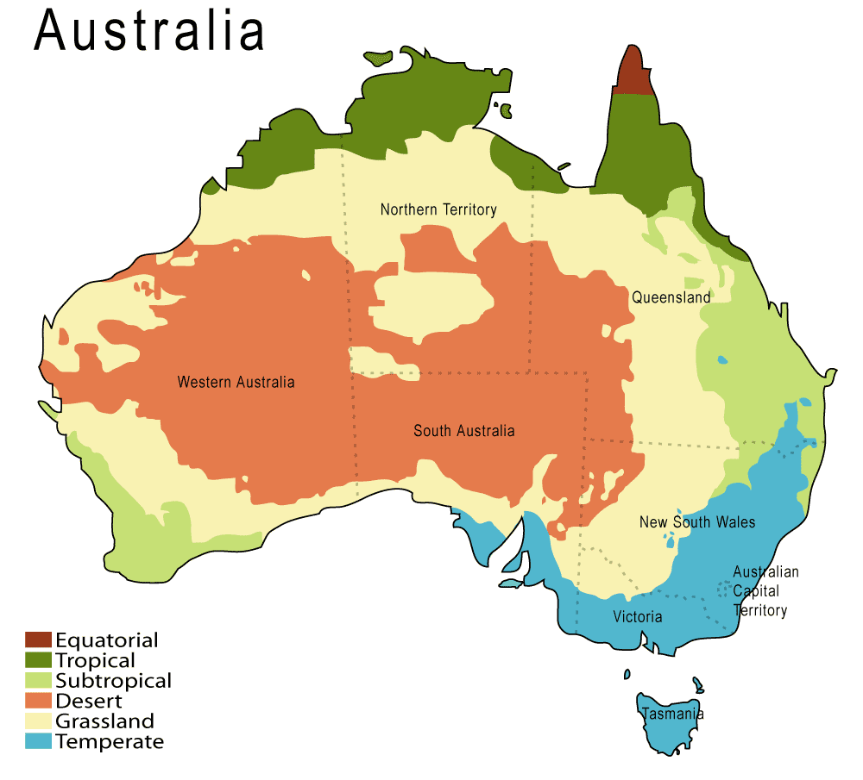
Australia, Today
Originally composed of six separate colonies of the British Empire, Australia's path to independent statehood began with the formation of a federal state in 1901 and was largely complete by World War II. The last few remaining constitutional links with the United Kingdom were severed in 1986, although Australia remains part of the Commonwealth, and The Queen is the head of state, represented by a governor-general.
The government formally apologized in 2008 for the past wrongs committed against the indigenous Australians, who still suffer from high rates of unemployment, imprisonment and drug abuse.
Today, Australia ranks as one of the best places to live in the world by all indices of income, human development, healthcare and civil rights. The sixth-largest country in the world by land mass, its comparatively small population is concentrated in the highly-urbanized east of the Australian continent.
Interesting notes about Australia: The island continent combines a wide variety of landscapes. These include deserts in the interior, hills and mountains, tropical rainforests, and densely-populated coastal strips with long beaches and coral reefs off the shoreline. Through its isolation from other continents, Australia has developed an abundance of unique plant and animal life, most famously marsupials such as the kangaroo.
Summarize the information above, highlighting what Australia was like before British imperialism; why/how Britain imperialized Australia; the effects of imperialism on the aborigines; and what Australia is like today.
__________________________________________________________________________________________________________________________________________________________________________________________________________________
___________________________________________________________________________________________________________________________________________________________________________________________________________________________________________________________________________________________________________________________________________________________________________________________________________________________________________________________________________________________________________________________________________________________________________________________________________________________________________________________________________________________________________________________________________________________________________________________________________________________________________________________________________________________________________________________________________________________________________________________________________________________________________________________________________________________________________________________________________________________________________________________________
_________________________________________________________________________________________________________

